**Experiment -3.1**

**Student Name:** Ankesh kumar **UID:** 22BDO10014

**Branch:** AIT-CSE(DevOps) **Section/Group**: 22BCD-1/A

**Semester:** 4th **Date of Performance:** 06/03/2024 **Subject Name**: Git and Hub **Subject Code:** 22CSH-293

1. **Aim/Overview of the practical:** Compare the changes in the Git Repository
2. **Software Used:** Git Bash, GitHub.
3. **Steps for experiment/practical:**
   * Create a new repo on the local machine.

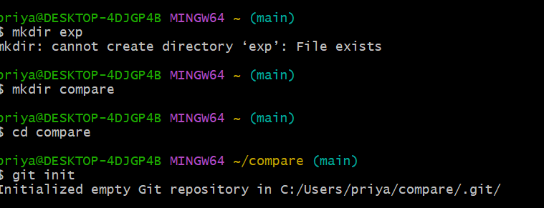

* + Create a new file in the **master** branch and write some content in it. Commit the changes

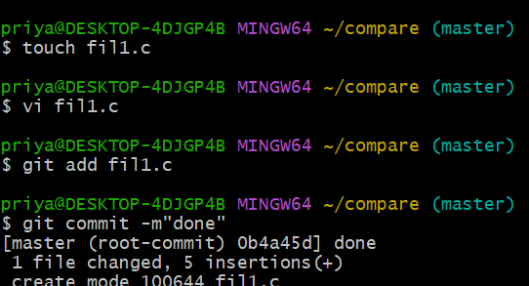

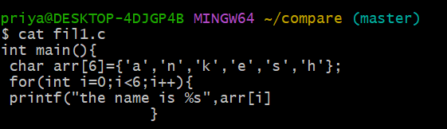

* + Create a new branch named **branch1** and checkout in that branch. Make some changes in

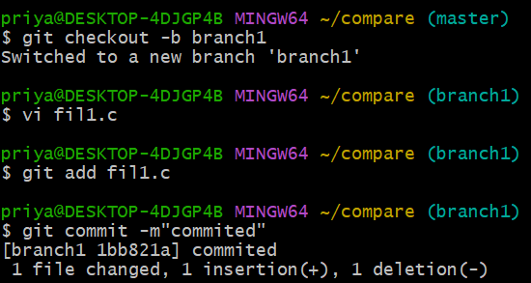

the file , i.e , **fil1.c** and commit the changes.

* + Checkout to the main branch and execute the **git diff main branch1** command to see the differences in the **fil1.c** in those branches.

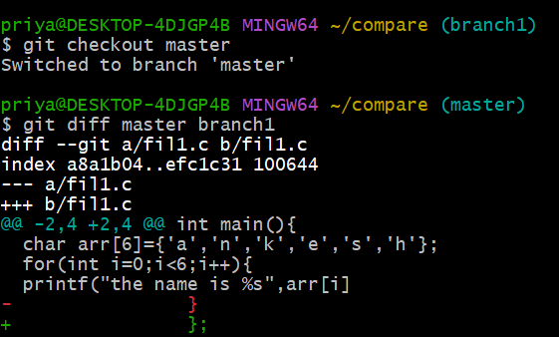

1. **Result/Output/Writing Summary:**

In this experiment, we have changed a file in the main and test branch and then shown the differences between the file in both the branches.

**Learning outcomes (What I have learnt):**

* + 1. Learnt how to create a branch.
    2. Learnt how to show the differences between the file using git diff.
    3. Learnt how to use the nano editor
    4. Learnt to checkout to a specific branch

**Evaluation Grid (To be created as per the SOP and Assessment guidelines by the faculty):**

|  |  |  |  |
| --- | --- | --- | --- |
| Sr. No. | Parameters | Marks Obtained | Maximum Marks |
| 1. |  |  |  |
| 2. |  |  |  |
| 3. |  |  |  |